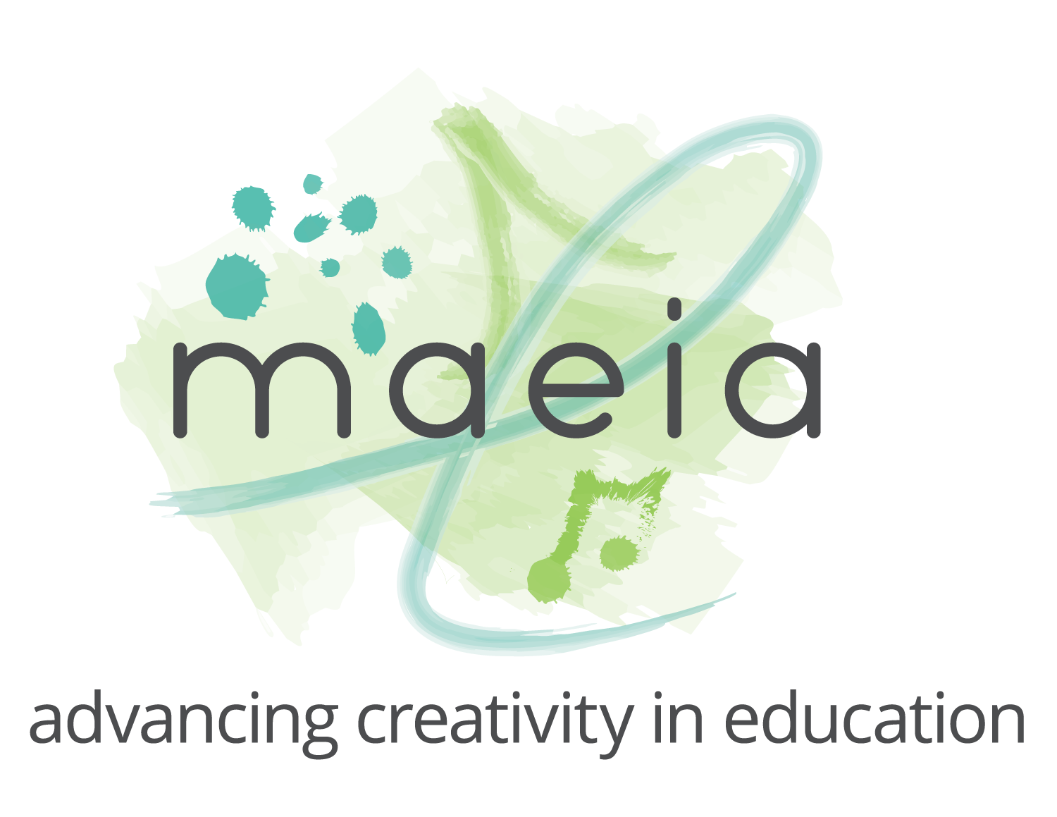
MAEIA SAMPLE 2023-24 Music Grant (33c) Application
This document is intended to support the application process for K-5 schools currently without a music program. Districts may download this sample and modify as needed. The district’s responses to the following questions will be uploaded in a pdf format to the application platform. The budget will be entered separately. Use the budget template in advance of entering the application platform for an efficient and expedient application process.

District Name Millville School District

District Code

Building Name Millville Elementary

Building Code

Grade levels in building:
Total number of students in any and all grade levels, K-5: 450

Staffing
☐ A teacher has been hired: Name of Teacher assigned to lead new music program: Teacher Endorsement – check all that apply: ☐ JX ☐ JQ PIC Code:

X A teacher will be hired and we will update this template when hired.

Curriculum
We are developing a curriculum based on the Sample K-5 Music Curriculum Map developed by the Michigan Arts Education Instruction and Assessment (MAEIA) project. This sample curricula aligns with national and state standards and recommends MAEIA performance assessments for each unit to determine student growth. As we implement the curriculum, we will make modifications based on student needs and educator expertise with awareness of representation in content featuring artists who mirror the students’ cultural identity as well as artists who offer new perspectives beyond students’ lived experiences.

A free K-5 music curriculum map can be found by scrolling to the Sample Instructional Materials on MAEIA’s Instructional Resources page. (Image of Page 1 of the music curriculum map is included below for visual reference, not required in the application).

Materials and tools
The tools and materials needed in support of the curriculum map noted above include:
- Instruments and repair: recorders, drums
- Recording equipment
- Software
- Sheet music
- Puppets or other teaching tools
- Books

Schedule
45-minute sessions, two days per week

Sample Schedule: (two classes at each grade level, meeting twice weekly)
Mondays K-A, 1-B, 2-B, 3-B, 5-A
Tuesday K-B, 1-A, 3-A, 4-A, 5-B
Wednesdays K-A, 2-A, 3-B, 4-B, 5-A
Thursdays K-B, 1-B, 2-B, 4-A, 5-B
Fridays 1-A, 2-A, 3-A, 4-B

Describe the space dedicated to this music program
Music classes will take place in the cafetorium until a dedicated music classroom can be established. Our goal is to create a music classroom that aligns with the ideal standard outlined in the Michigan Blueprint for Quality Arts Education.

Budget
Use the budget template provided by MDE in preparation of your grant application. Please refer to the RFP for allowable expenses.
